Original tumor (2026) with PIP5K1A WT and KO Analysis

The raw sequence files from the sequencing company underwent alignment and mapping steps using the online platform, GALAXY. The files were first organized into paired collections, which then underwent Quality Control (QC). Since none of the files showed the necessity to be trimmed, they were subjected to the mapping step using RNA-STAR tool on Galaxy, with the gene annotation file provided as GTF file. The resulting BAM files were inputted into the FeatureCounts tool on Galaxy from which the count files were obtained as tabular files. These files were uploaded to R for further local analyses.
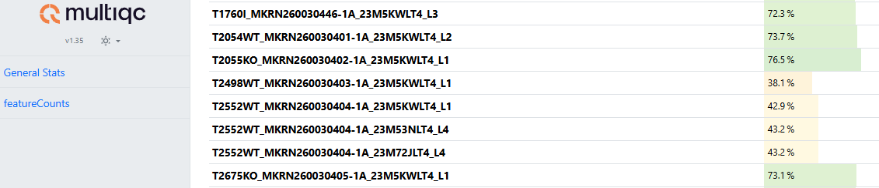
QC was run on all count files to check for assigned percentages. 3 files that belonged to the original tumor collection showed low assigned percentages for their sequences. The table below shows these files.

The sample file T2552WT had three replicates since the sequencing company, Novogene, noticed an unusually high RNA rate in this sample, which lead them to prepare a new library and run two replicates of the same sample. All three resulting samples gave a low-than-optimum assigned percentage during QC. They were later combined in R into one sample count column, as advised by the sequencing company.
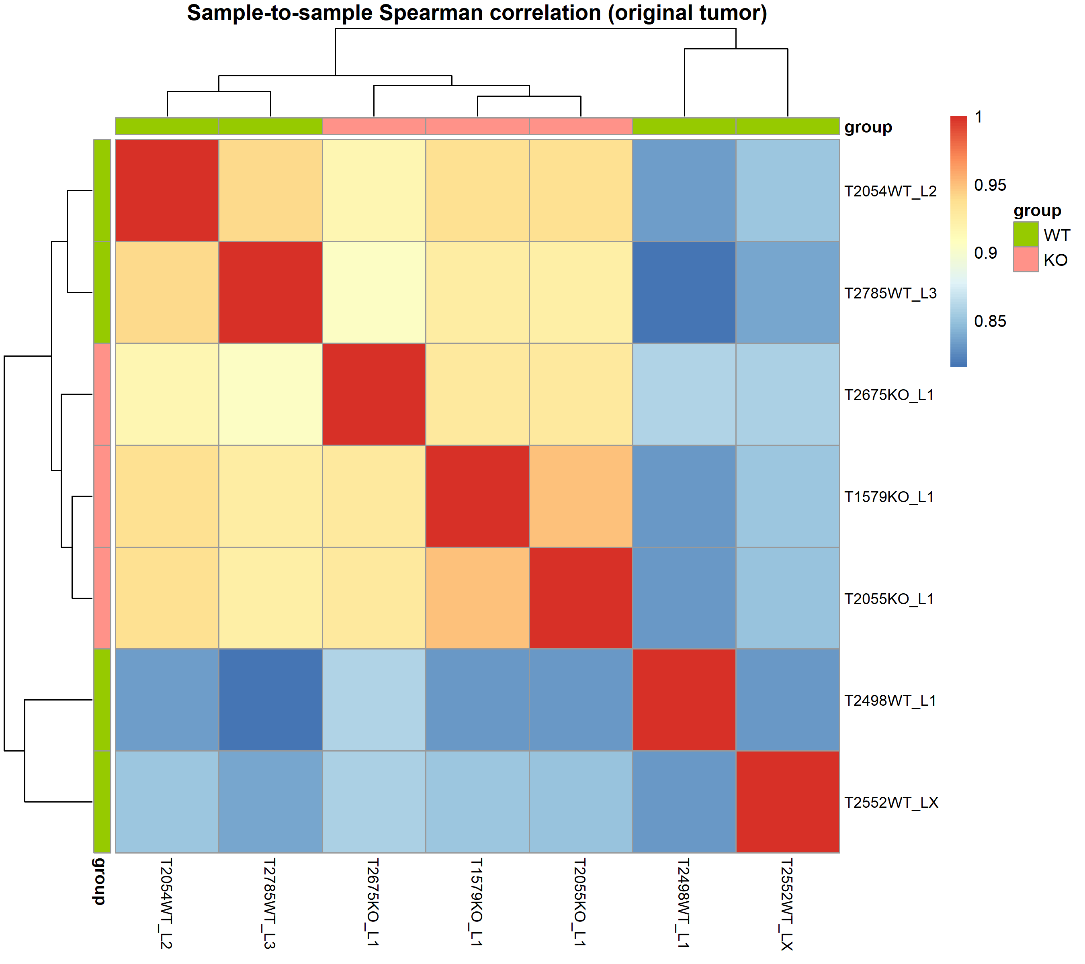
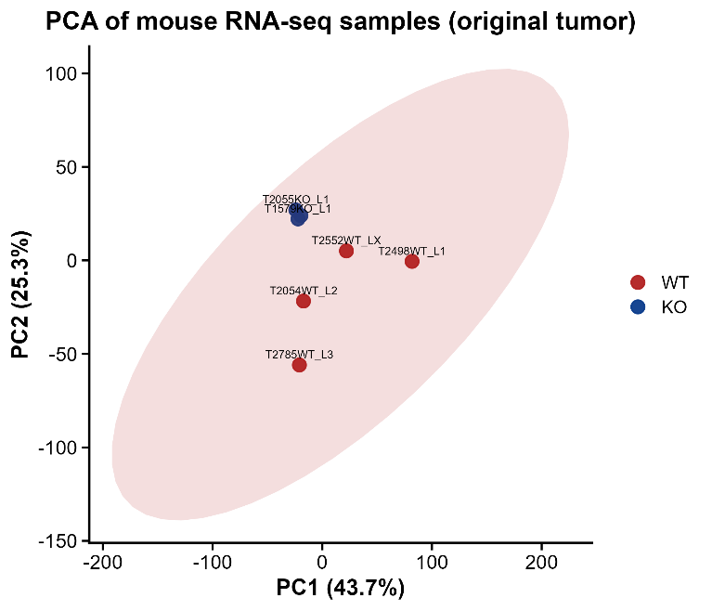
Once uploaded to R, PCA clustering and heatmaps were carried out, both filtered and unfiltered for low quality samples. The first two images below are unfiltered, followed by the filtered plots.

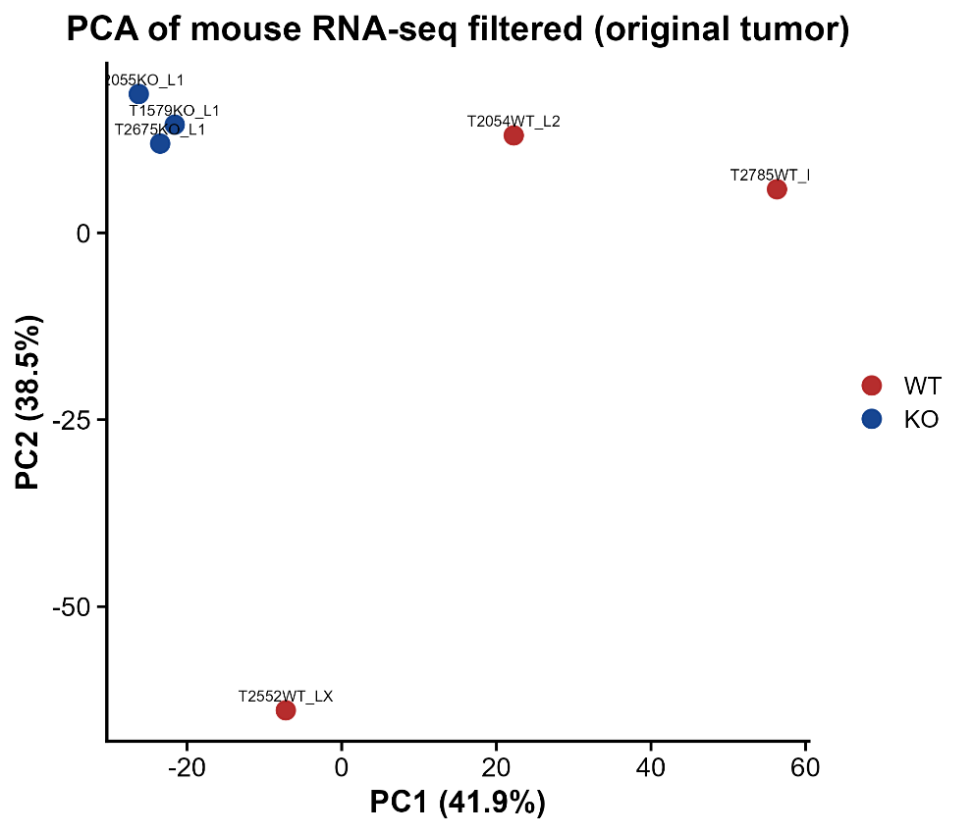

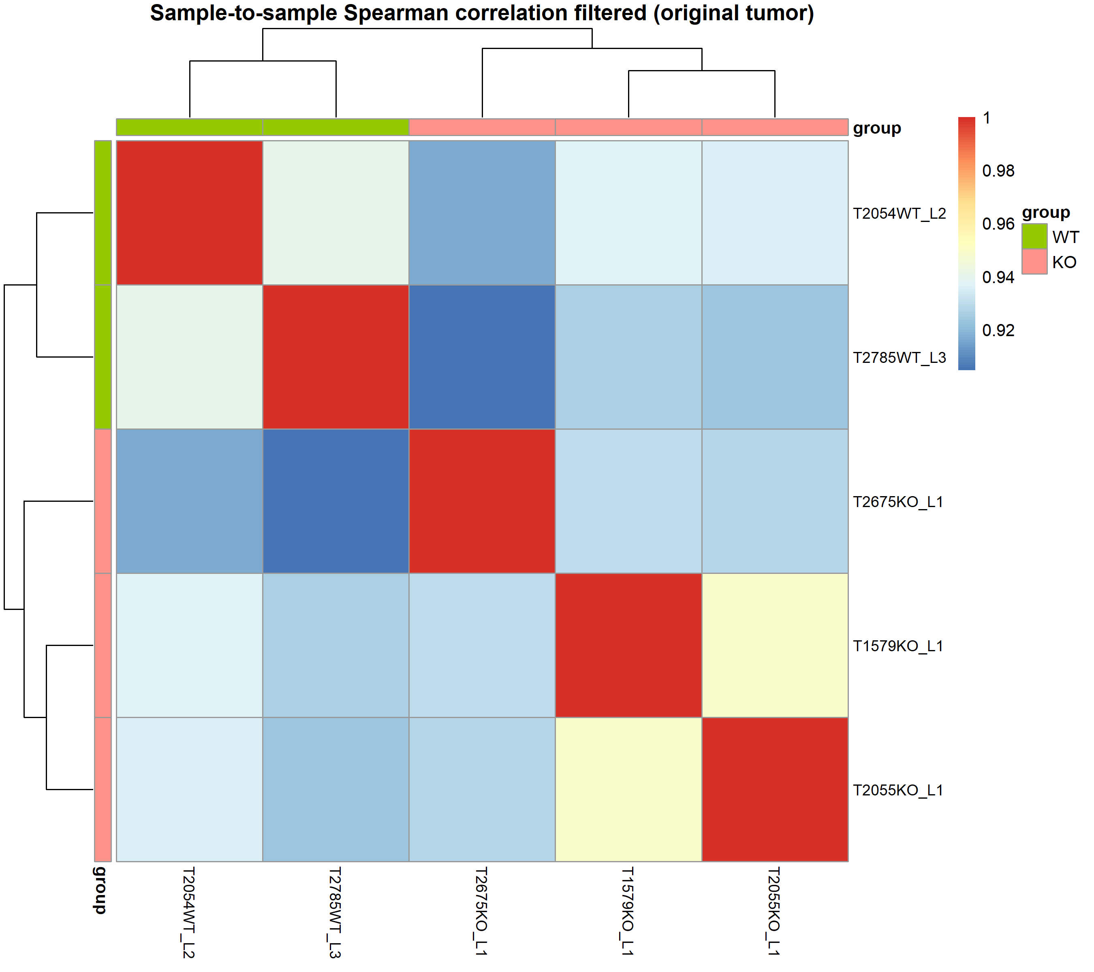

The resulting plots show that, during PCA, the Knock-Out (KO) samples seem to cluster very close to each other, whereas the Wild Type (WT) samples are responsible for most of the variance in PC1, suggested by the large scattered placements of them within the PCA plot. The filtered heatmap however shows that the two groups cluster separately from each other when sample-to-sample spearman correlation is considered. The two low quality WT samples seem to affect the reliability of the statistical significance once filtered out.
Following PCA clustering, Differential Expression Analysis was carried out between the two groups in order find the top significant DEGs, which consequentially were used for pathway enrichment analyses. Below are heatmaps representing how the sample cluster based on DEGs, as well as a table figure summarizing the DEG characteristics.
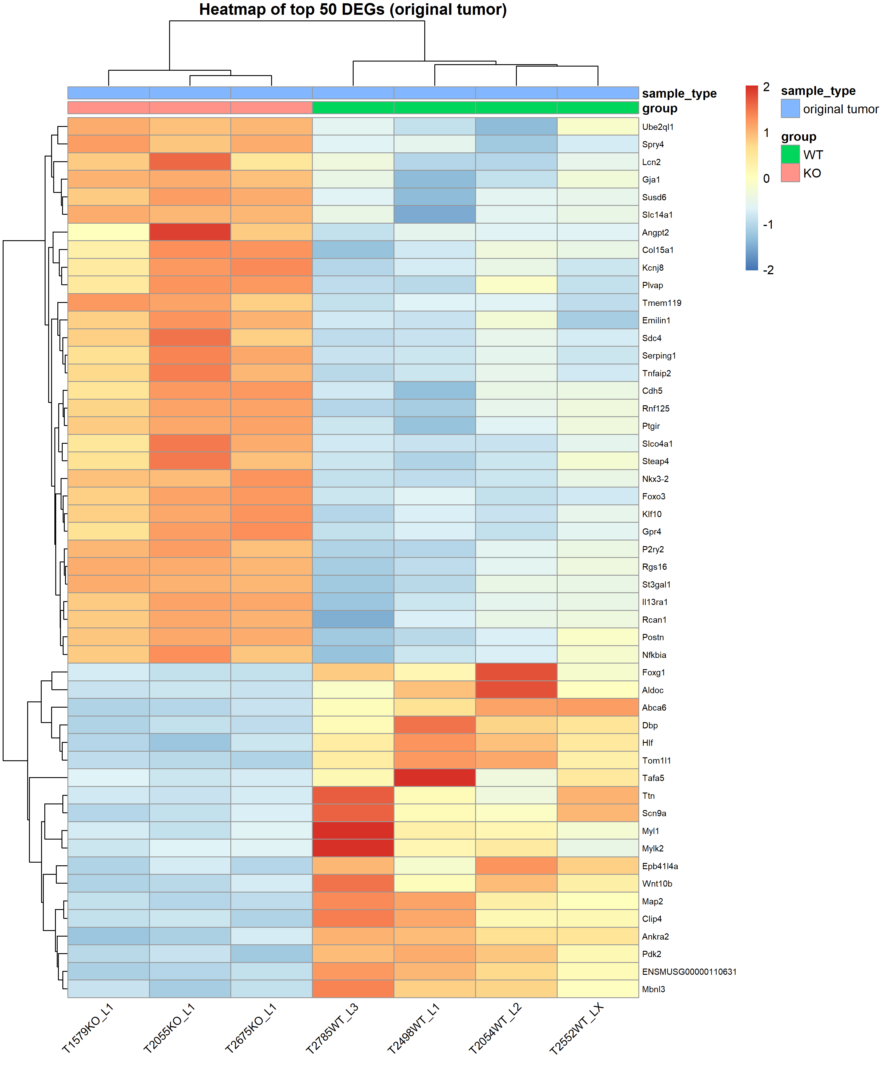
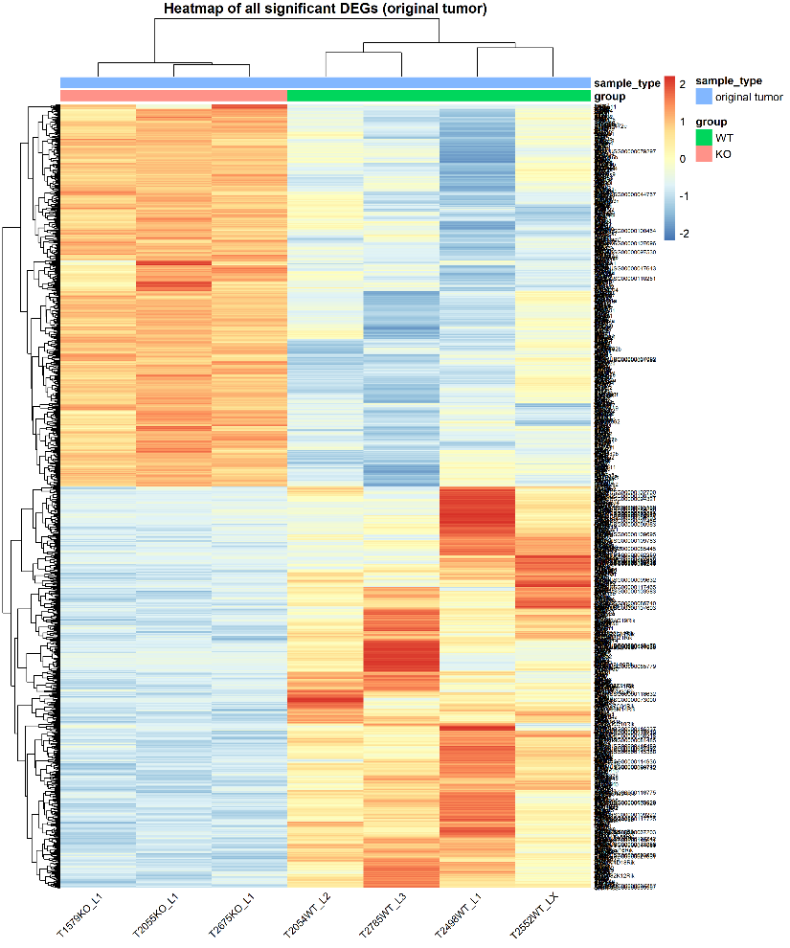

The gene of interest, FOLH1, which codes for the PSMA protein in many cancers, appeared on the DEG list as the 511th DEG with an adjusted p value of 0.011. Alongside FOLH1, three other genes that were also within the interested biomarkers looked into showed statistically significant differences between the two groups. Below is a summary of these significant biomarkers.
Biomarker | Relevance
FOLH1 | Encodes folate hydrolase 1, a type II transmembrane glycoprotein state. Through its folate hydrolase activity, FOLH1 mediates folate absorption in the gut.
RB1 | A tumor suppressor that restrains the G1/S cell cycle transition by binding and inhibiting E2F transcription factors in its hypo-phosphorylated state.
MYC | Encodes a basic helix-loop-helix transcription factor that functions as a nuclear phosphoprotein in cell cycle progression, apoptosis, and cellular transformation. Amplification of MYC is frequently observed in numerous human cancers.
TTF1 | Encodes transcription termination factor 1, a nucleolar factor that plays a critical role in ribosomal gene transcription. terminates RNA polymerase I transcription. Pathogenic association reported in hepatocellular carcinoma.
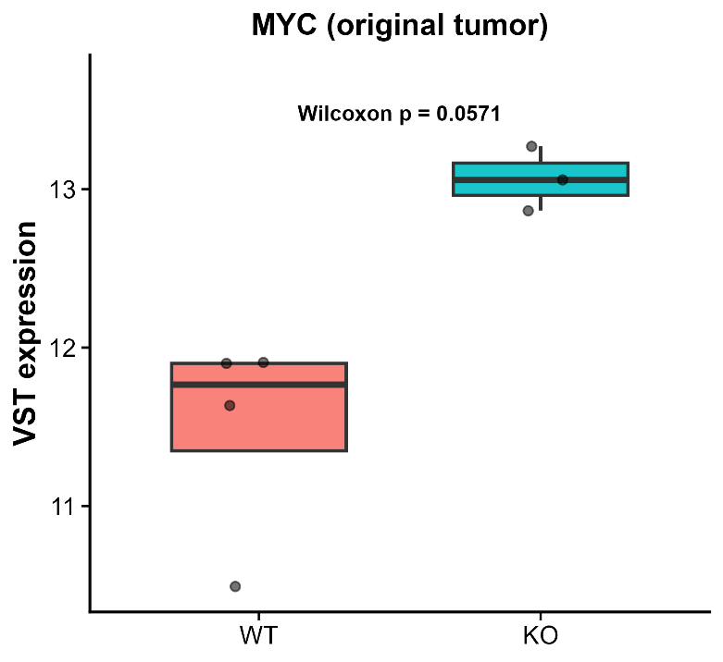
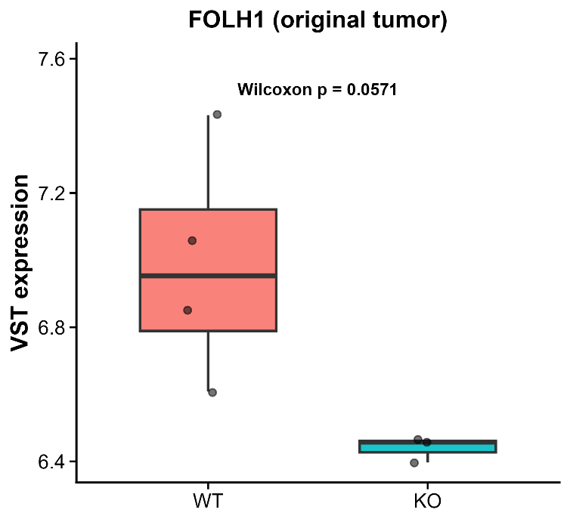
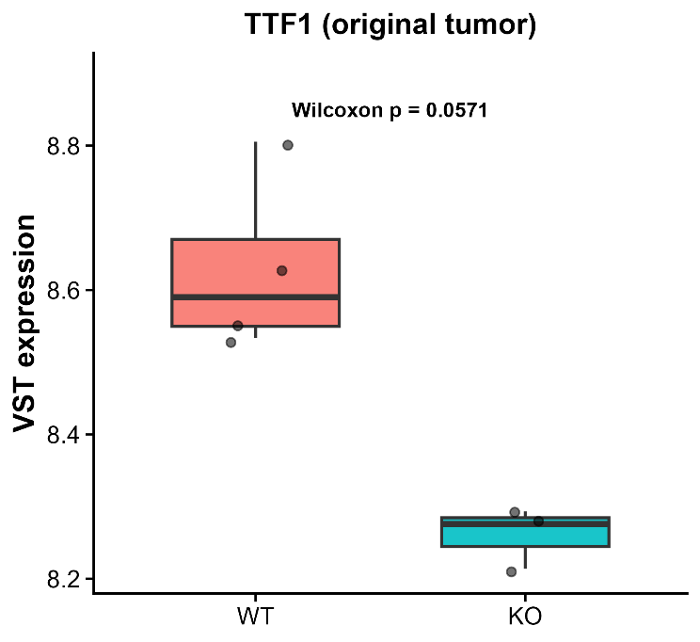
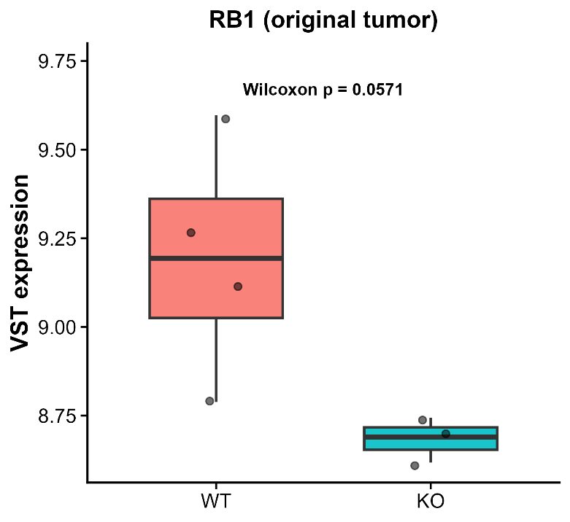

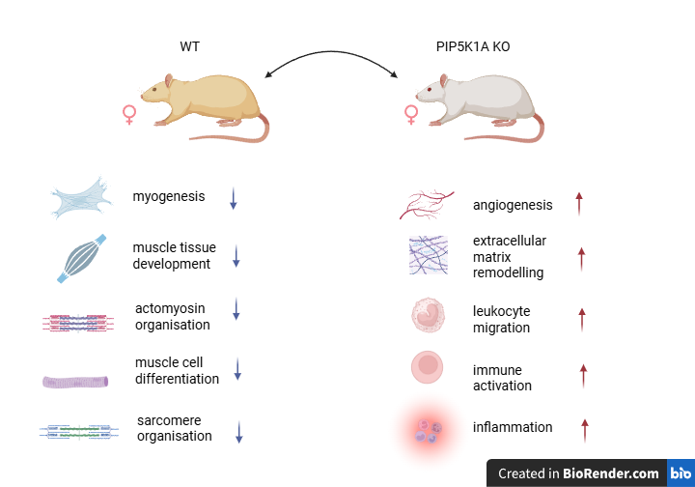
Like previously mentioned, using these DEGs, enrichment analyses were carried out on a GSEA basis, for GO BP, HALLMARK and ImmuneSigDB pathway methods. Using the results of these enrichments, the most interestingly differentially enriched and suppressed pathways were identified and looked into, defined by the illustration below.

This summary indicates that the WT and PIP5K1A-KO tumors occupy different microenvironmental states. The WT tumors show stronger contractile and muscle-like stromal signatures, whereas the KO tumors show increased angiogenesis, extracellular-matrix remodeling, leukocyte migration, and inflammation. Thus, PIP5K1A loss appears to be associated with remodeling of the tumor microenvironment toward a more vascular and immune-infiltrated state. However, the GSEA results do not by themselves establish whether this immune infiltration is antitumor or immunosuppressive.
Next, the list of interesting biomarkers for prostate cancer, both long established as well as new neuro-endocrine biomarkers from hypotheses, were looked into within these samples to see if they have any relationship with the expression of FOLH1. Both spearman and Pearson correlation tests were carried out for this purpose, spearman since it’s the most robust when the characteristics of data are considered, and Pearson in order to get a better scale void of the ranking system of spearman.
The Biomarkers that showed a significant correlation with FOLH1 are listed below, including their corresponding spearman rho and p value.
AR | 0.75 | 0.0522
MYC | -0.964 | 0.000454
NKX3-1 | 0.867 | 0.0115
RB1 | 0.857 | 0.0137

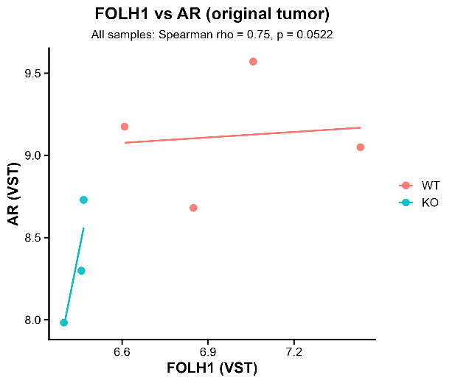
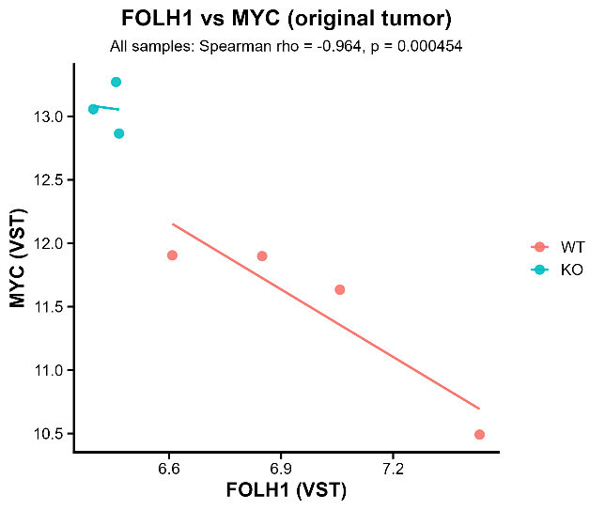

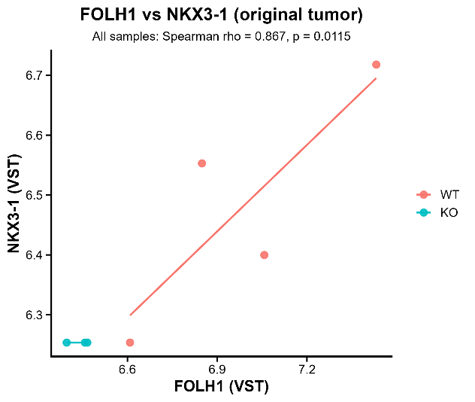
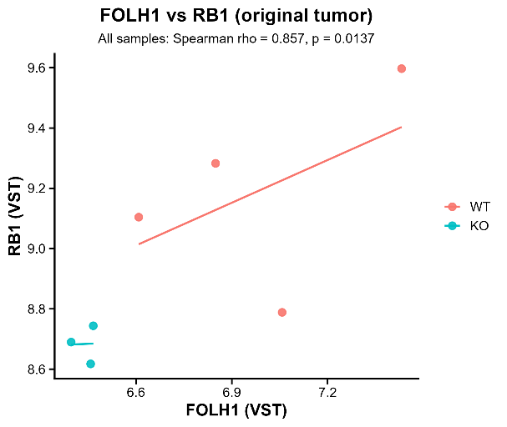

The combined Bar plots with Pearson’s correlation for both the KO and WT sample groups separately can be seen below.
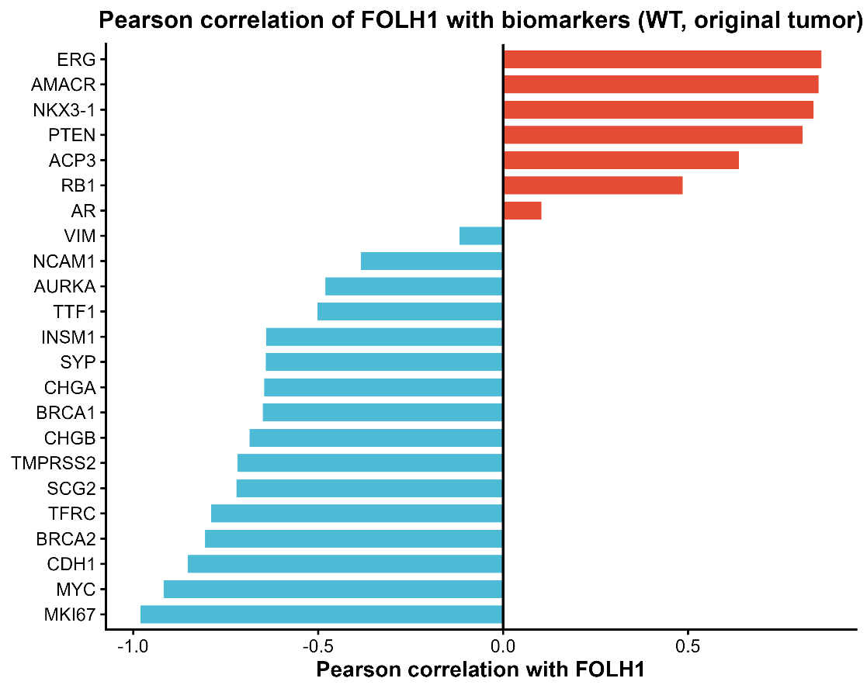

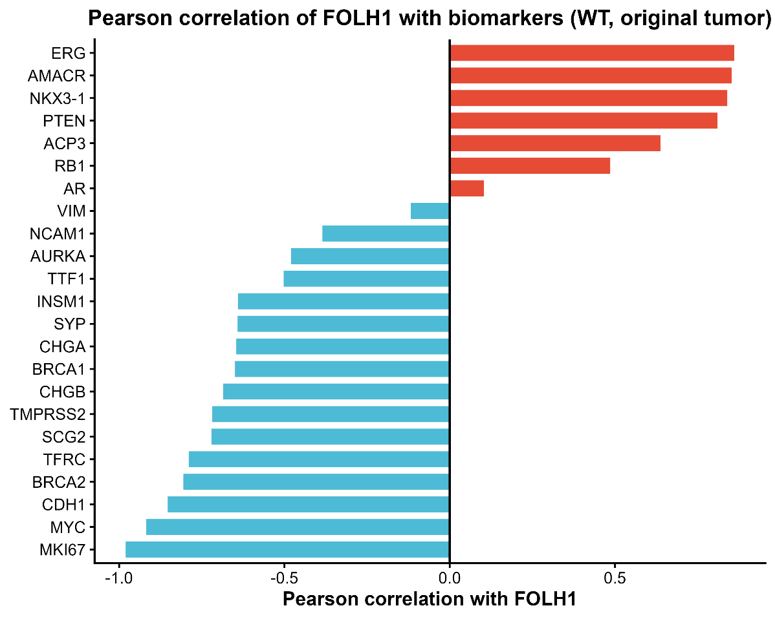

Next, in order to understand the abundance of immune and stromal cell populations within the bulk RNA data, MCP-counter analysis was carried out where the score for each MCP group was calculated for each of the two design groups, and compared. MCP counter groups that showed a significant difference between WT and KO are seen below.

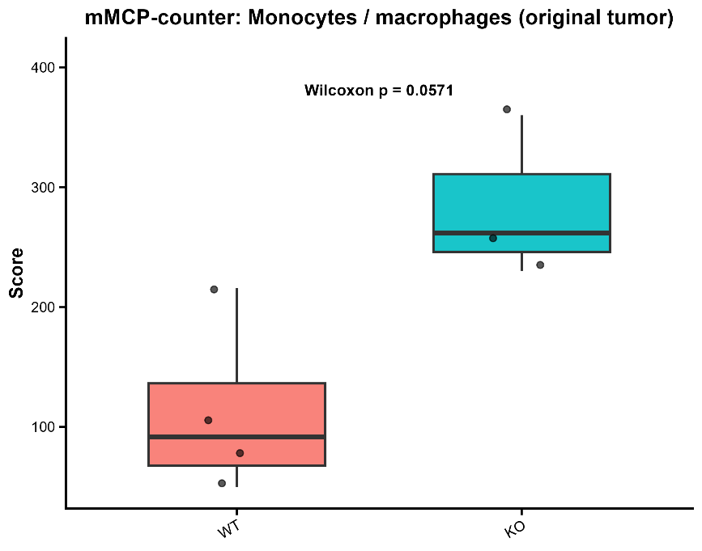
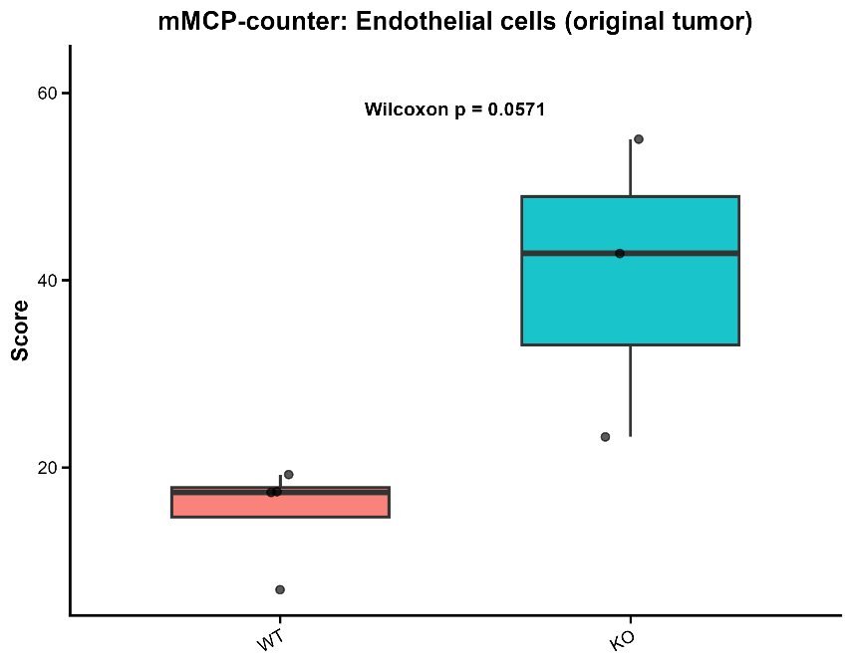

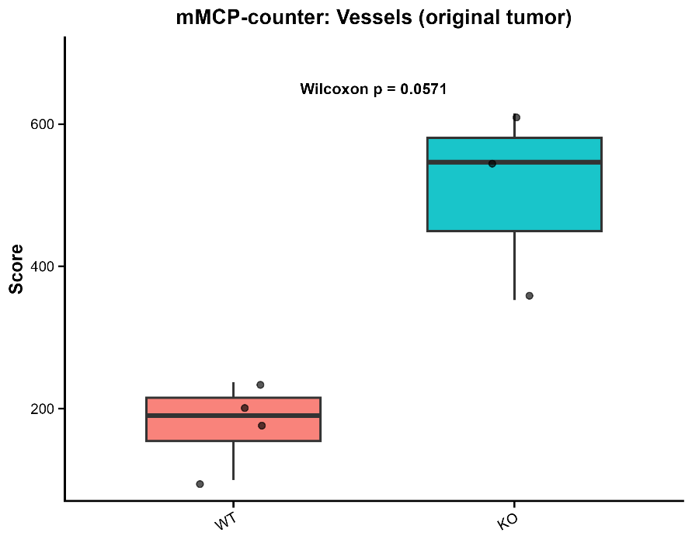

PIP5K1A-KO tumours showed consistently higher inferred endothelial-cell, monocyte/macrophage, and vessel scores than PIP5K1A-WT tumours. These trends were compliant with GSEA enrichment of angiogenesis, extracellular-matrix remodelling, leukocyte migration, and inflammatory programs in the KO state, suggesting a more vascularized and myeloid-associated tumour microenvironment following PIP5K1A loss. Differences were borderline by Wilcoxon testing (P=0.0571P = 0.0571).

Male v Female comparison across Syngeneic tumor controls from different treatment designs for PIP5K1A WT and KO
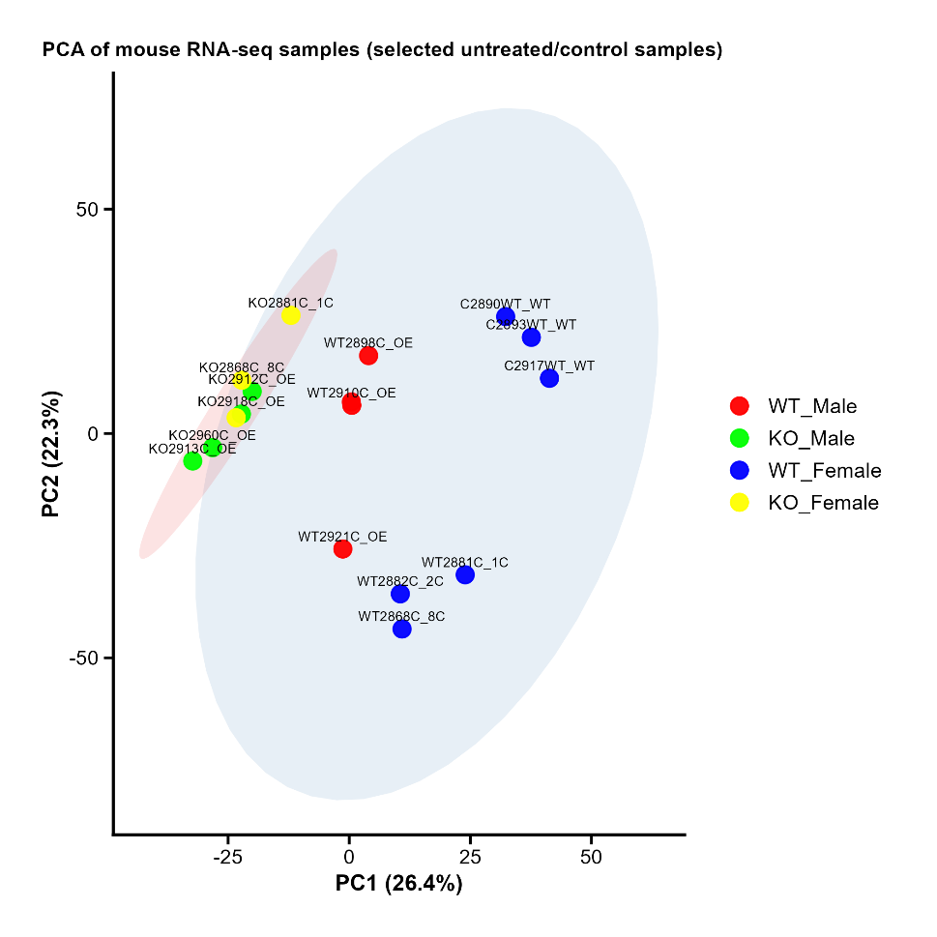
Similar to the previous analysis, the same was carried out, this time on syngeneic tumor samples throughout the years from different treatment designs. These samples acted as the controls for all these experiments. The original tumor cells are all female, but the implantations were done on mice of both sexes, and this analysis aims to find if there are any significant differences between them. The analyses carried out wont be explained as previously but the results are presented in the same order with an interpretation of each.

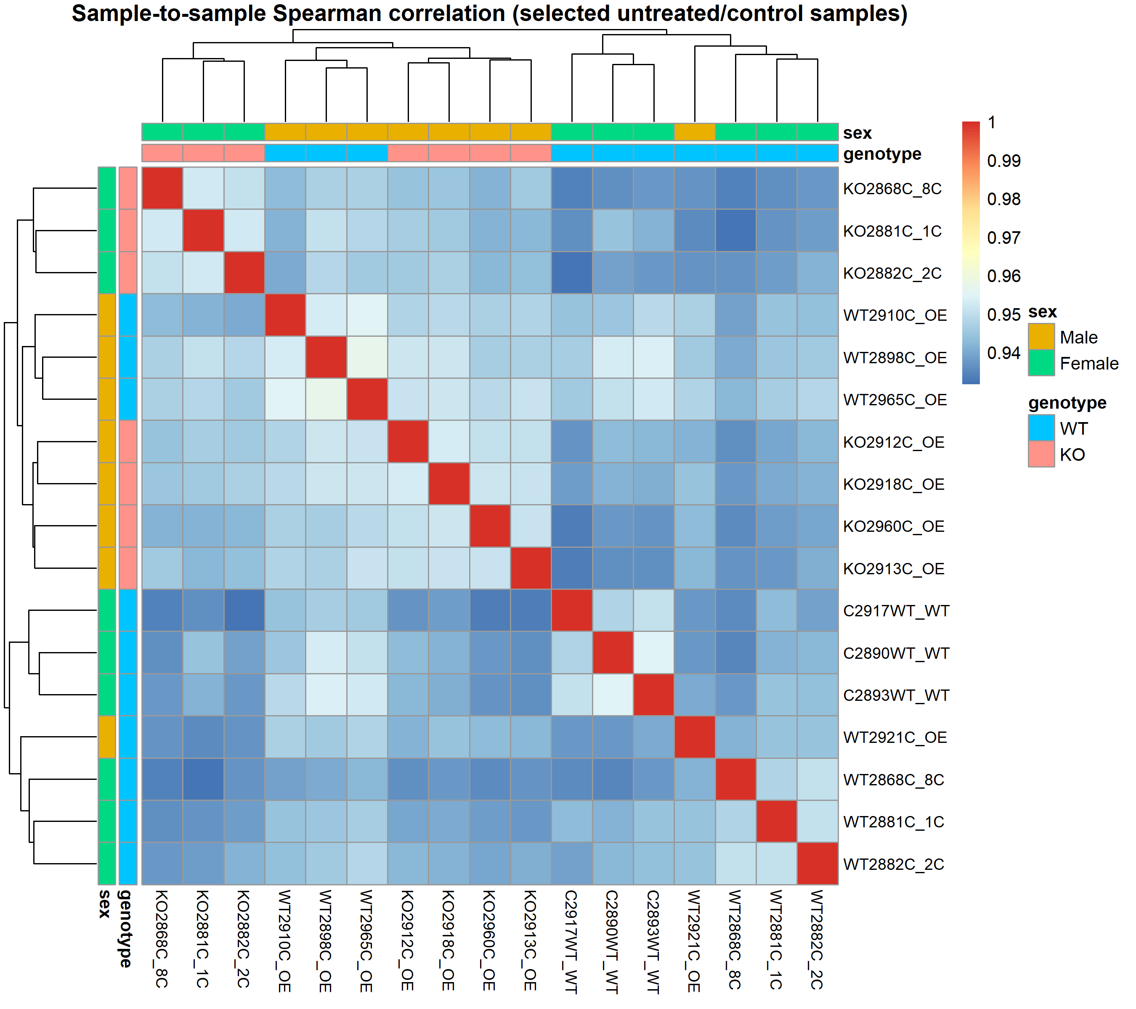

The PCA clustering of the samples showed that the KO samples seems to cluster together, without any sign of sex stratification, whereas the WT samples show some ambiguous clustering based on which experiment they belong to rather than based of sex.
The sample-to-sample correlation heatmap however shows that most male sample cluster together expect for one, whereas female samples form two/three separate clusters.
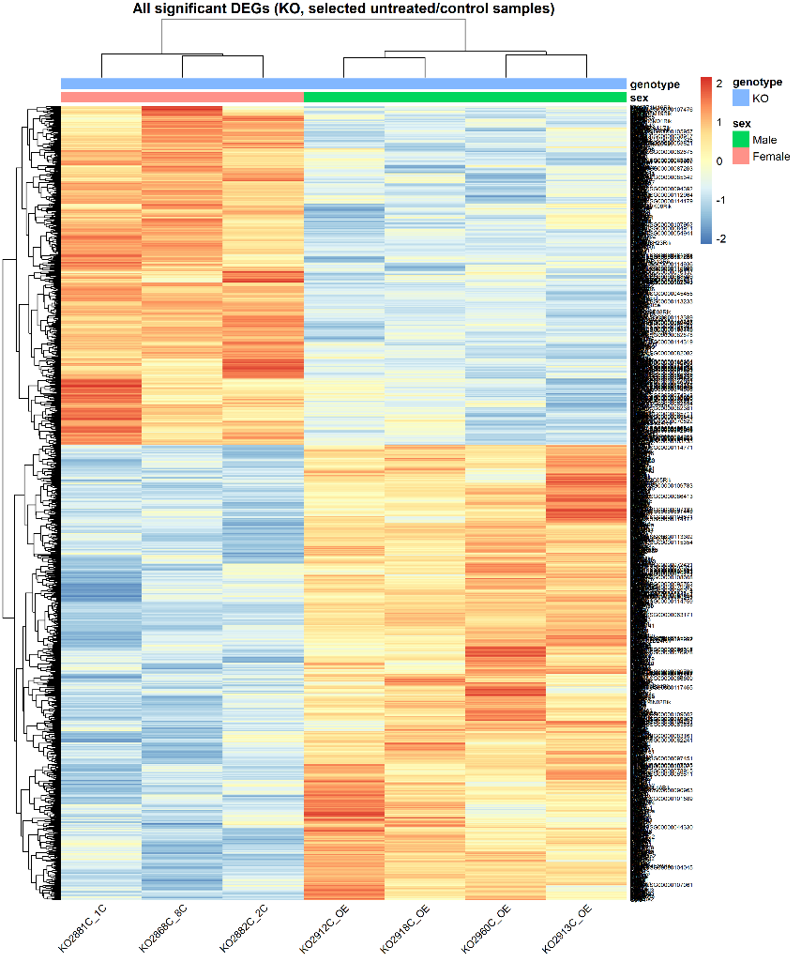
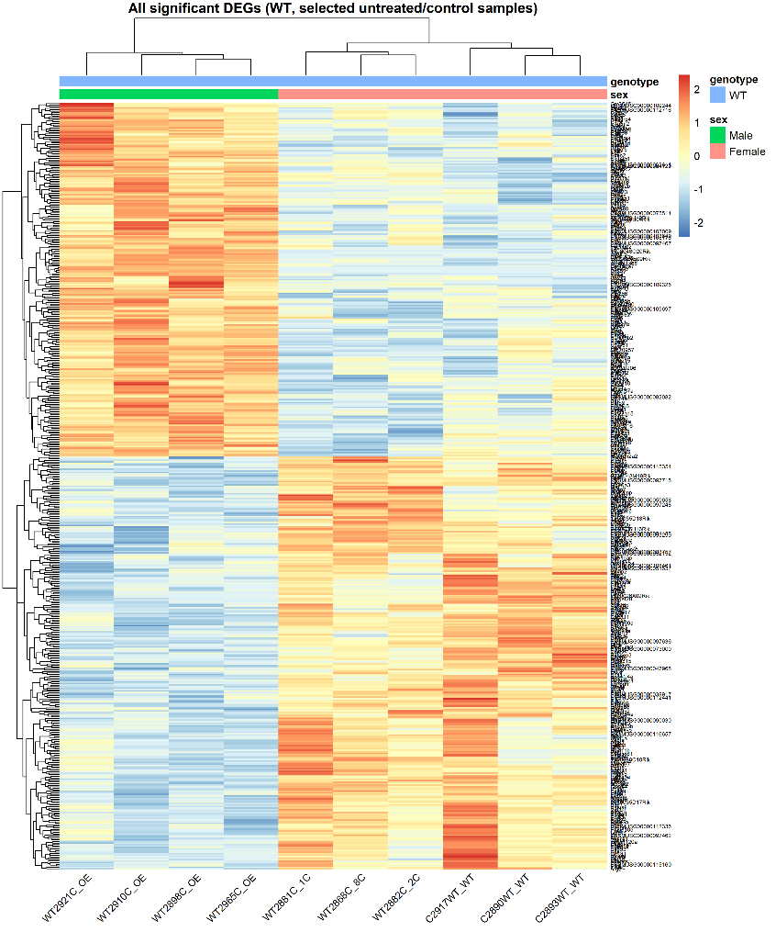

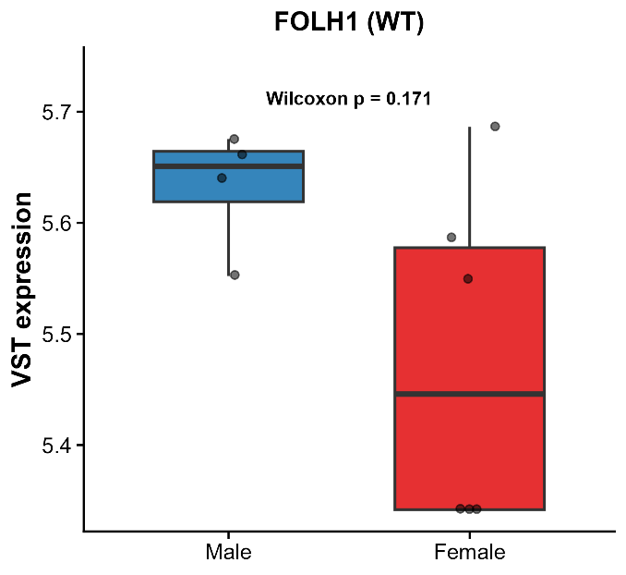
The DEG analysis was done separately on the Ko and WT groups, and the heatmaps of all significant genes show how the two sexes are stratified quite clearly in respect to these DEGs.
In WT samples, when looking at the expression patterns of the interested biomarkers list, only 2 showed significant expression differences: CDH1 and MKI67. I have also included the FOLH1 expression for comparison reasons, since that is what I am interested in.

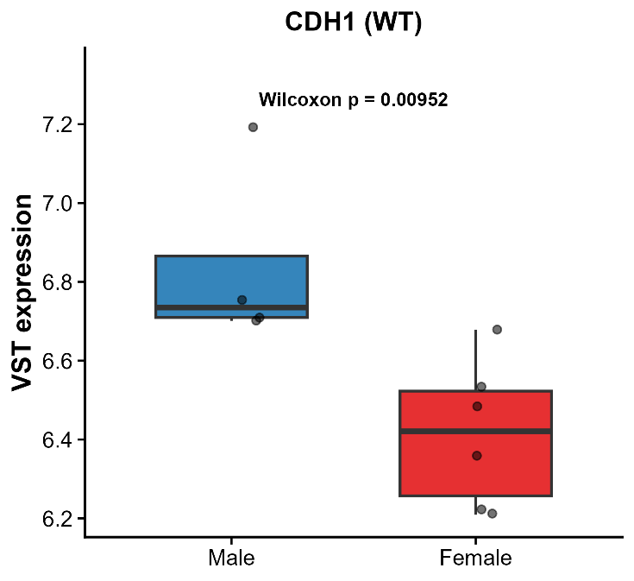
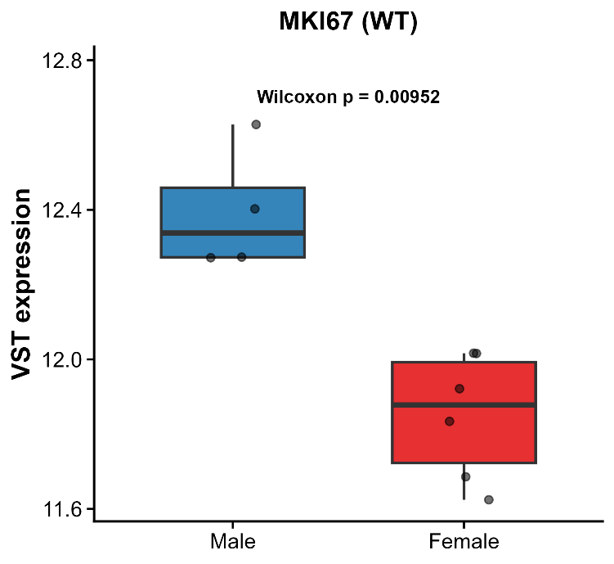
When looing at the KO samples, there were a greater number of interested biomarkers that showed significant differences between male and female, which is interesting to see that PIP5K1A KO affected the two sexes differently. Again, FOLH1 didn’t show a difference.
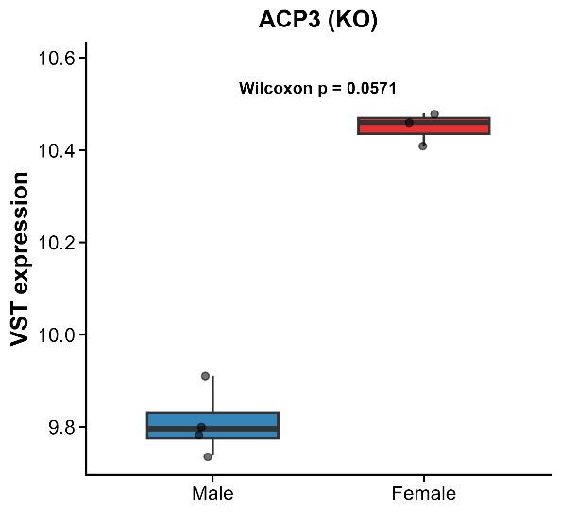
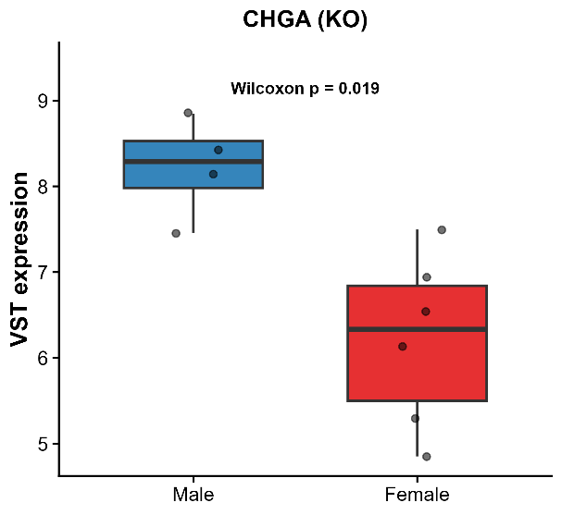

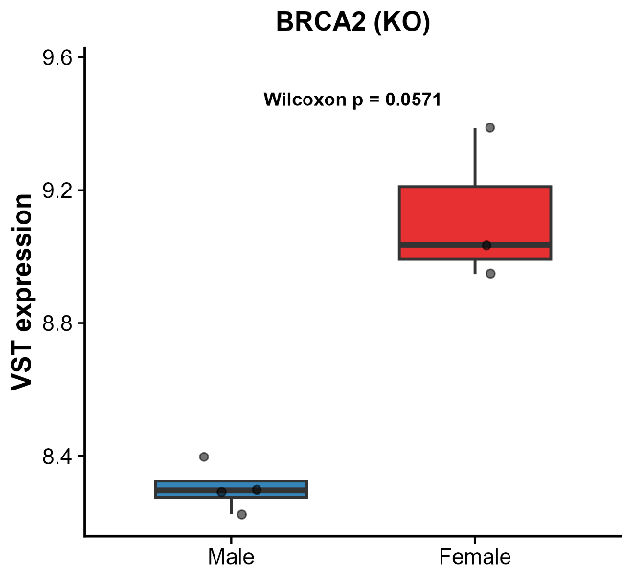
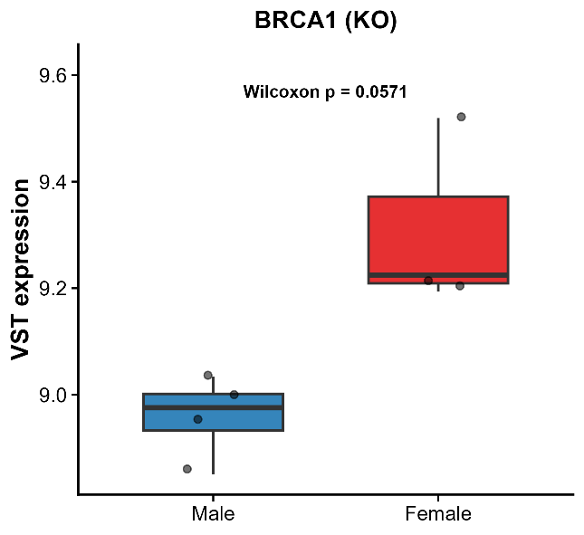

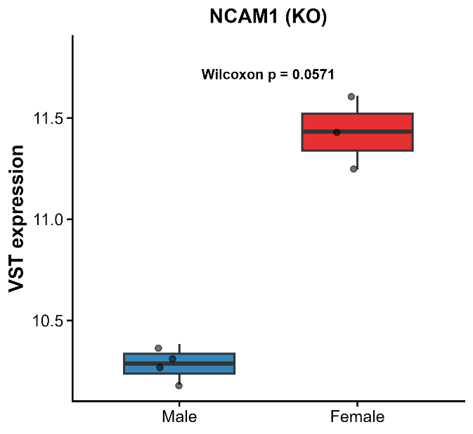
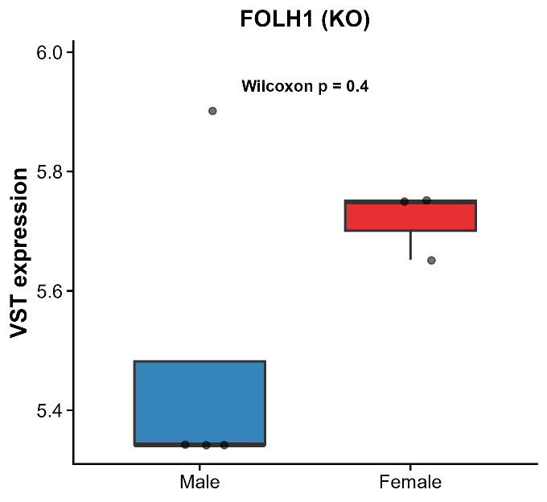
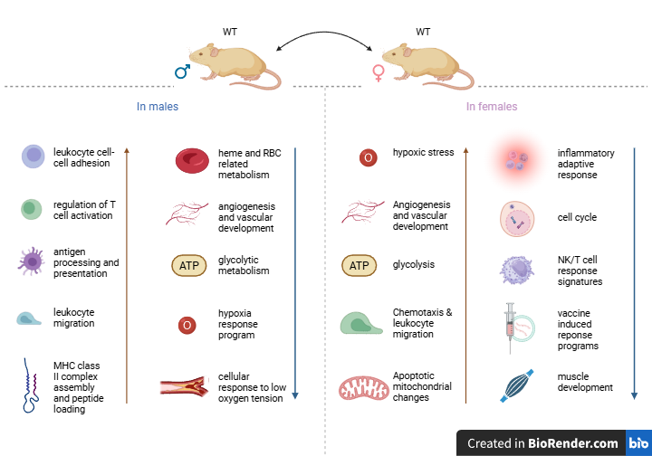

The pathway analysis suggests that male and female WT mice exhibit distinct but partially overlapping biological profiles. Both sexes showed enrichment of pathways related to immune activity, metabolism, vascular biology, and cellular stress responses. However, the specific pathways represented differed between males and females, indicating sex-associated variation in immune regulation, tissue-related processes, and cellular adaptation. Overall, these findings suggest that sex may influence the molecular programs active in WT mice.
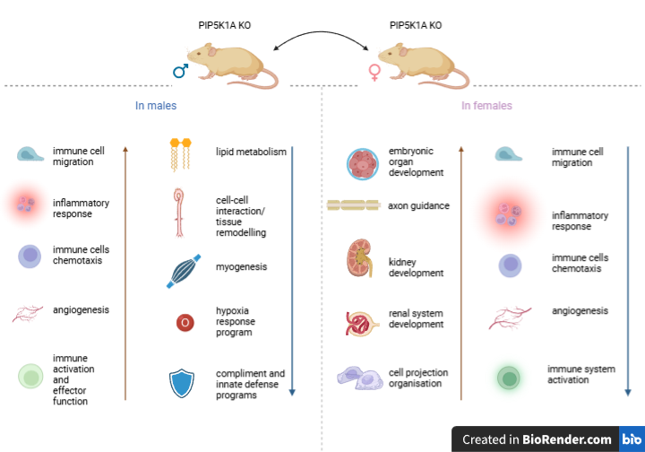
The pathway analysis suggests that male and female PIP5K1A knockout mice exhibit distinct but partially overlapping biological profiles. Both sexes showed enrichment of pathways related to immune activity, inflammation, cell migration, angiogenesis, and tissue-related processes. However, the specific developmental, metabolic, muscular, renal, and immune-associated pathways differed between males and females. Overall, these findings suggest that PIP5K1A loss may influence sex-specific immune, developmental, metabolic, and tissue-remodelling programs.
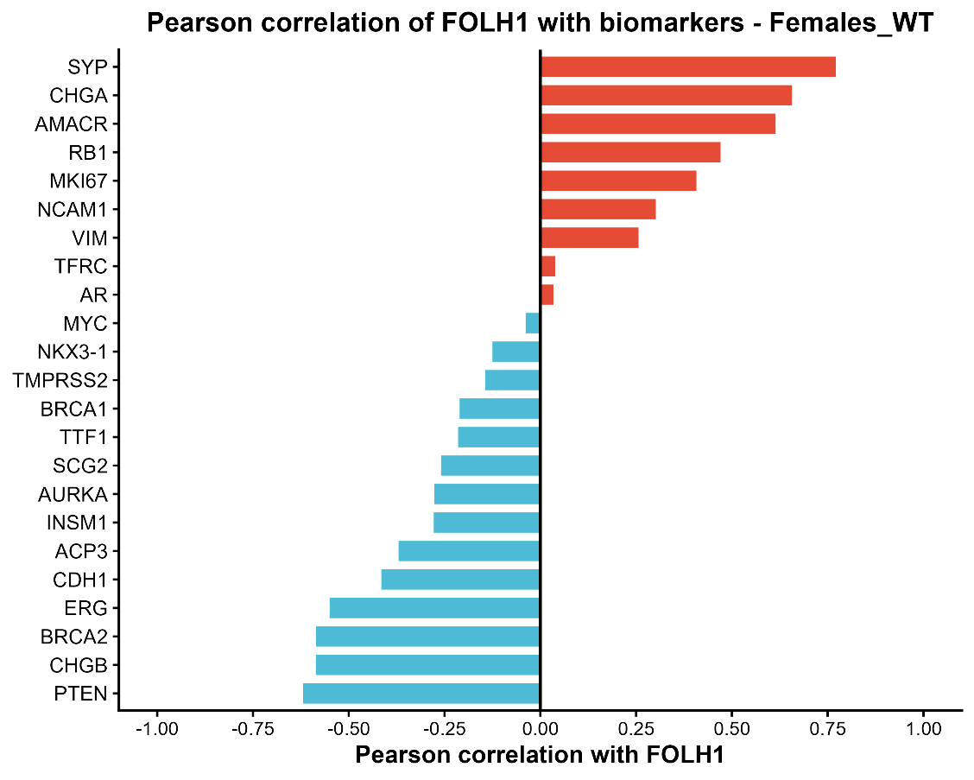

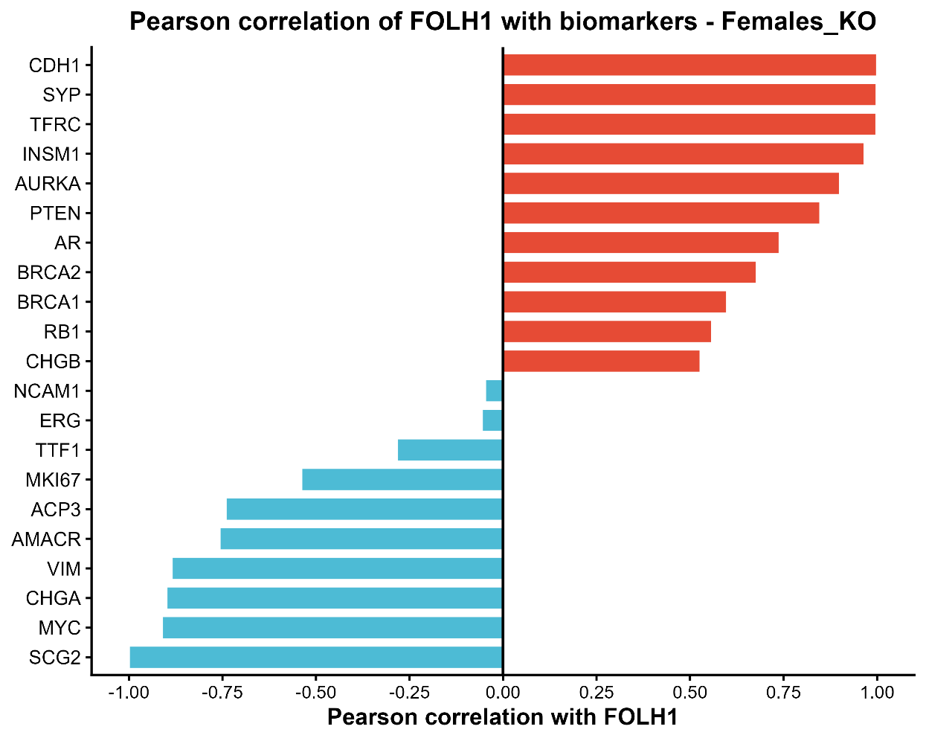

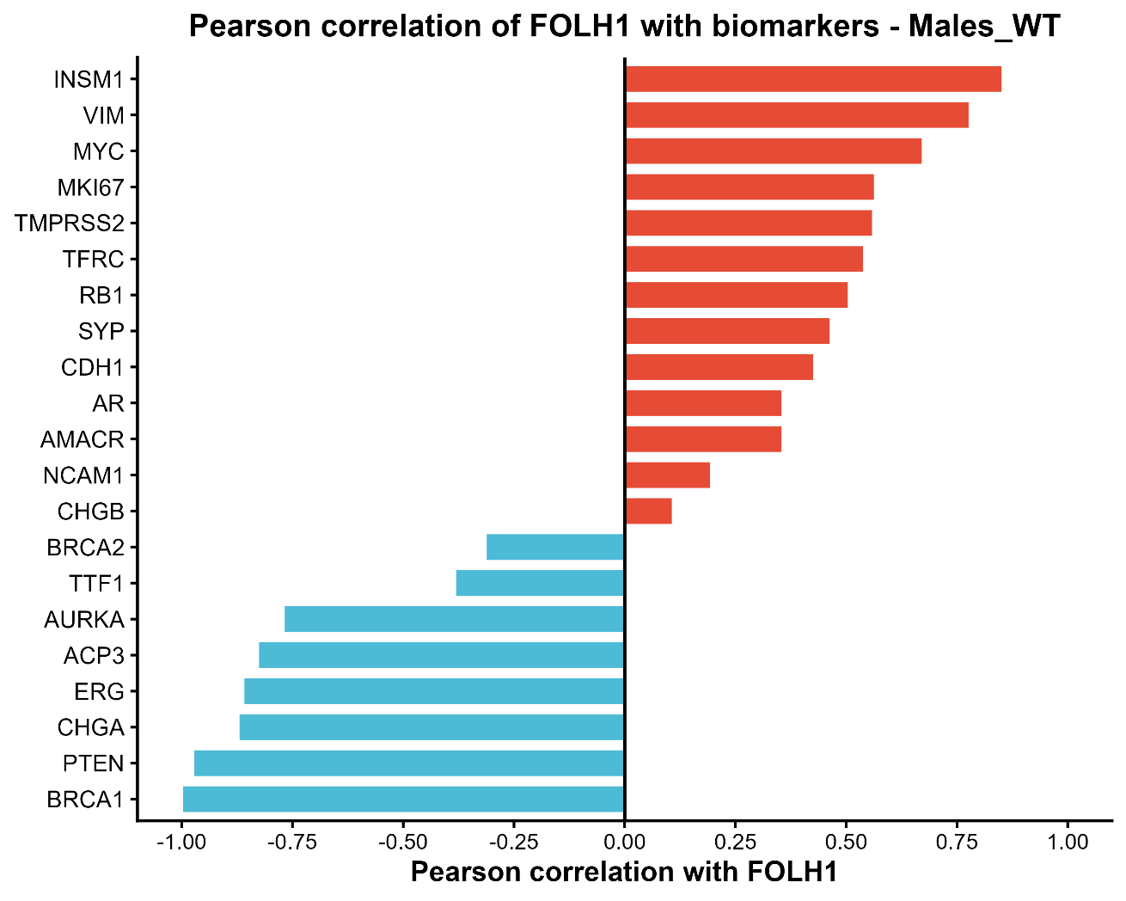

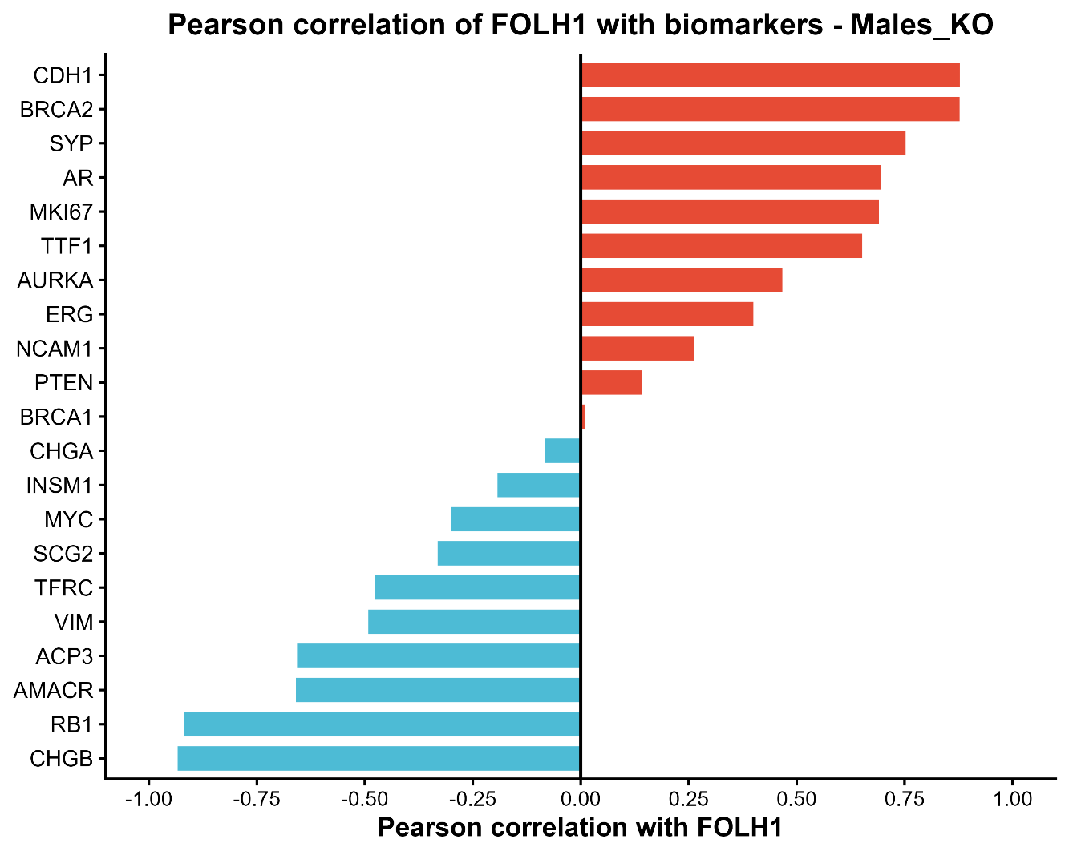

FOLH1 is associated with distinct biomarker expression programs in WT and PIP5K1A knockout mice. In WT animals, these relationships are more variable and appear to differ between males and females. In KO animals, the correlations become stronger and more polarized, with a clearer separation between positively and negatively associated biomarkers. Several genes, including VIM, MYC, BRCA1, PTEN, CHGA, and AMACR, show genotype-dependent changes in correlation direction, suggesting that PIP5K1A loss may remodel the transcriptional context in which FOLH1 is expressed. This effect also appears to be sex-dependent, as the magnitude and direction of several associations differ between males and females.
Following this correlation study, MCP-counter was used like previously, but this time, across for group combination. When comparing WT male and WT female populations, none of the MCP counter groups seemed to show a significant difference across the groups. But each of the other three combinations appear to show several significant or almost-significant differences.

KO-Male vs KO-Female
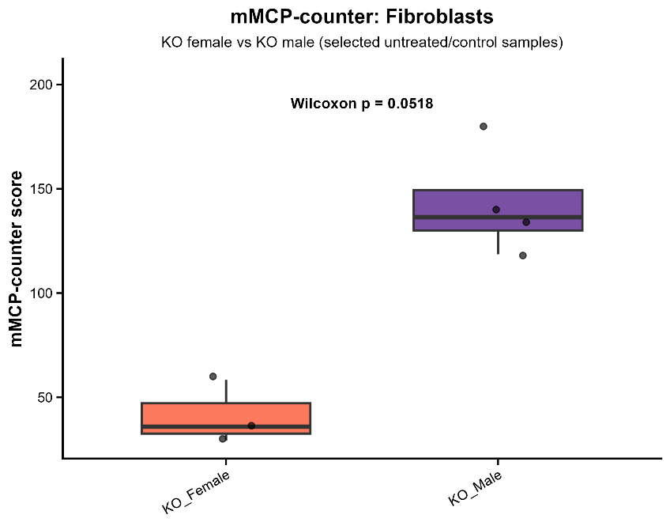
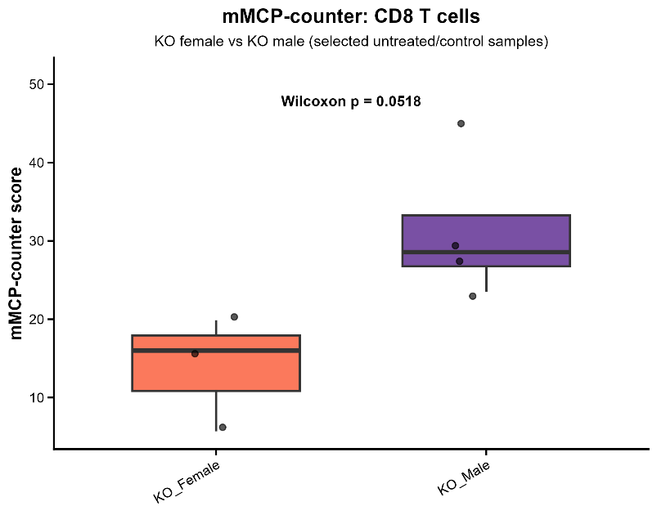
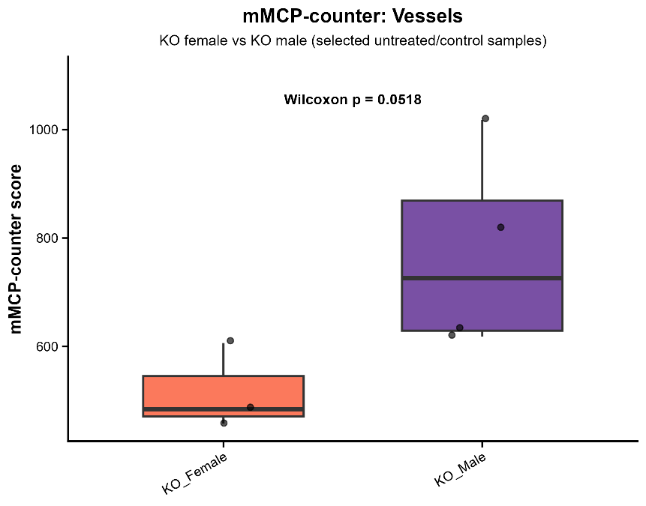

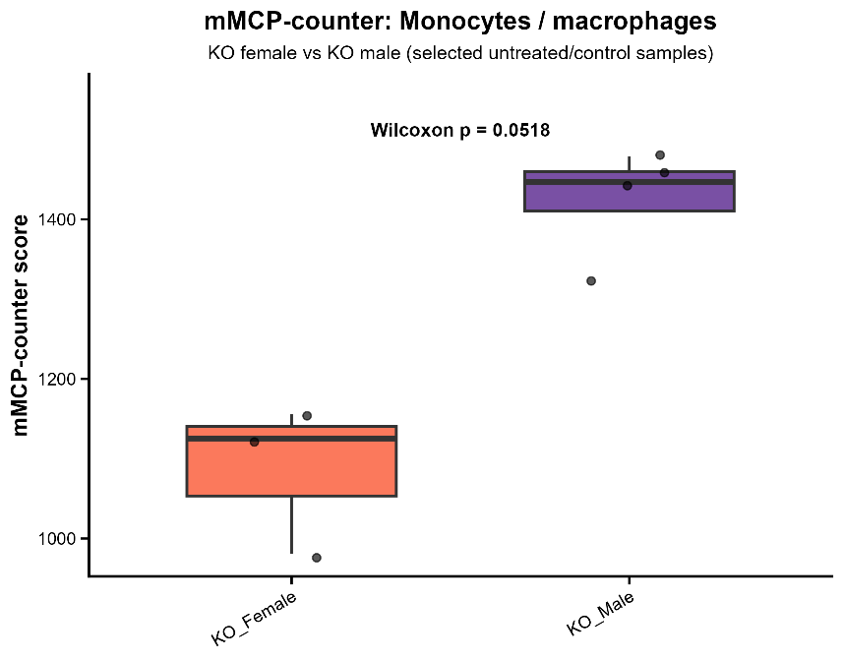

KO-Male vs WT-Male
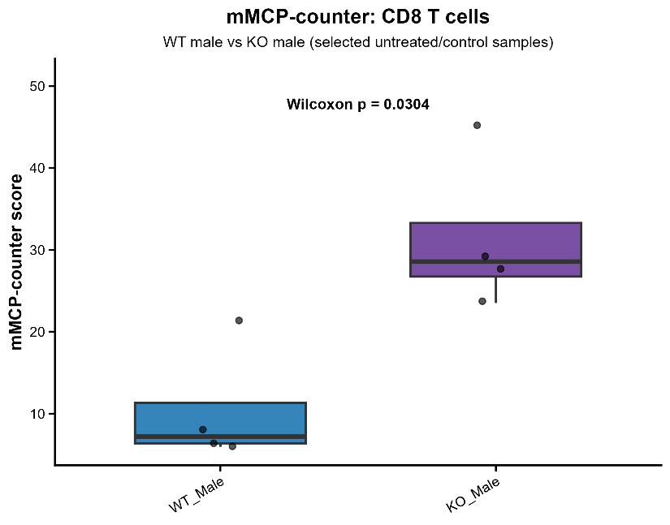
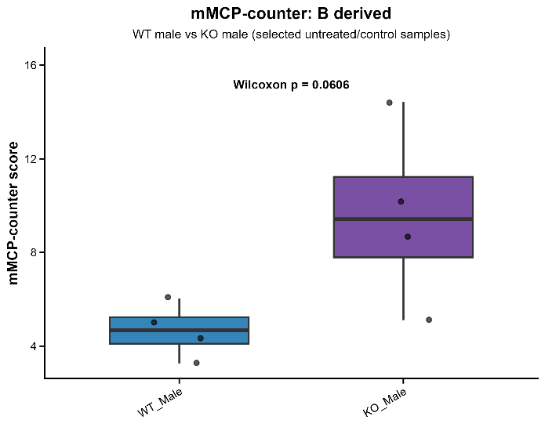
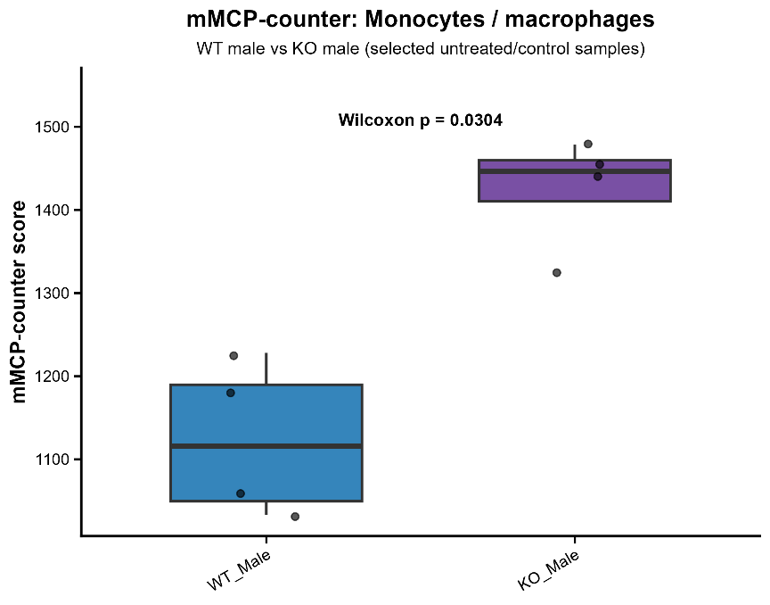
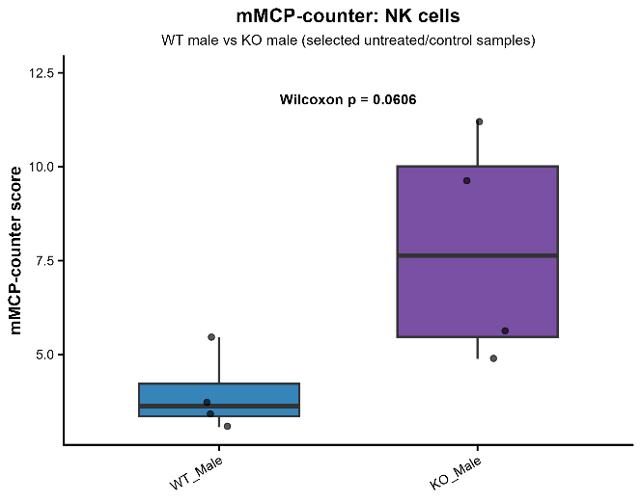
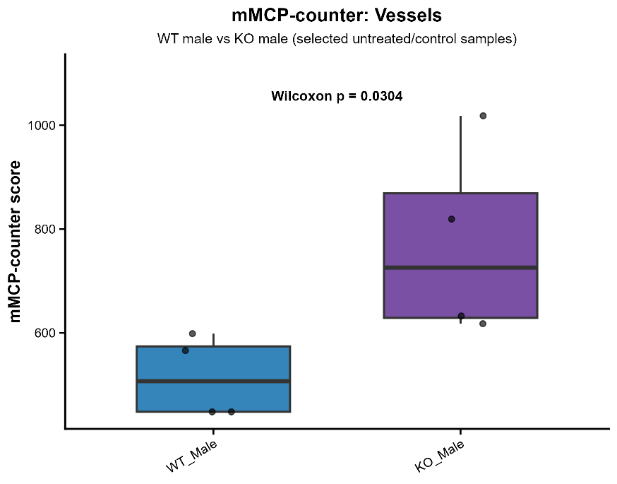

KO-female vs WT-female
